Lab Assignment-3

Reshma Reddy

16143725

Q1 Extend the Mobile Web Client Application you implemented in Lab 2 **with HTML5 Local Database**

Below is the Mobile Web Client welcome screen. The local database has been implemented with the

Weather service.

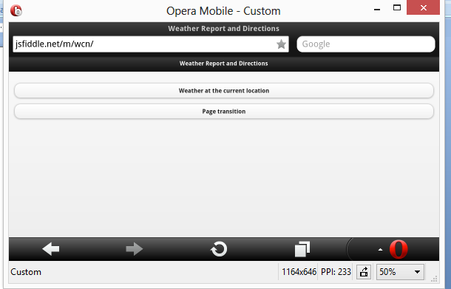

Below is the page transition from home page to the local Html 5 data base

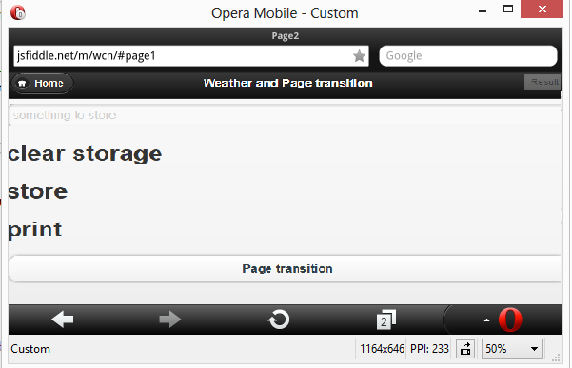

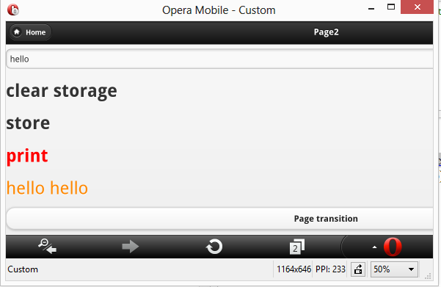

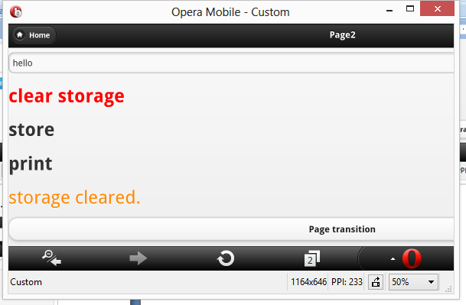

When moved to home page from there a weather page can be seen. This is he Weather feature in the application. It also Has atweet capability, where users can tweet current weather.

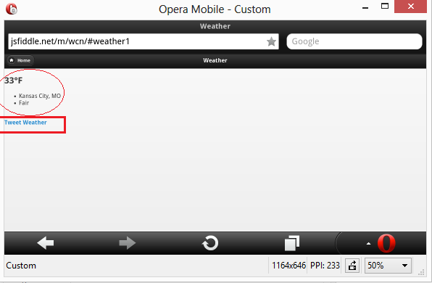

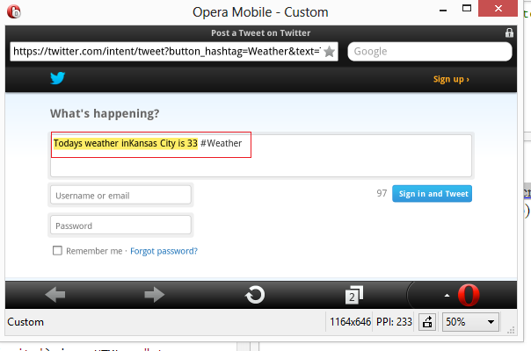

Q2. Make a Mashup application including various services (e.g., Google Map, Google Chart, Google

Search, Yahoo, Amazon, Twitter, Facebook) Web Services (e.g., Google Map Services, Weather

Services) for the application.

I used Google geo-location API and top of it kept Pictures of all the near by touristic destinations.

When clicked on the picture it gives the name and the a enlarged picture.

There is an another feature that is connecting to twitter.This is done by using twitter API.

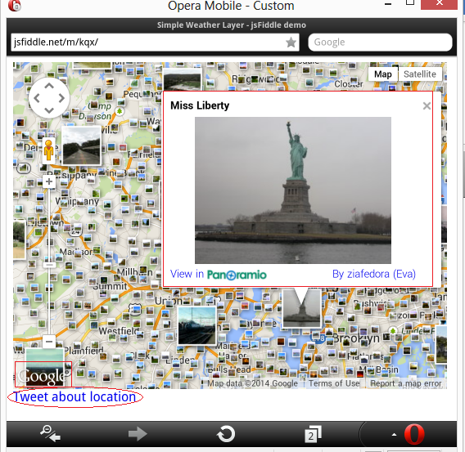

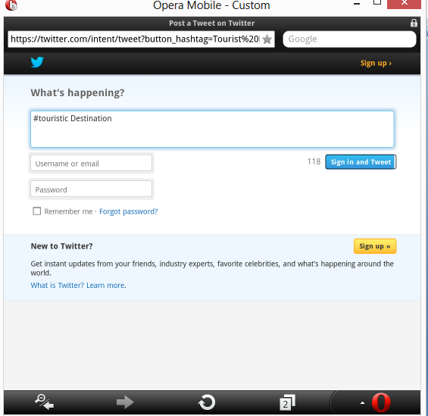

Q3 Implement your own REST Web Services and use them from your client application.

I am adding a user login feature to my web client using REST Web Services. The first screen of the web

client has been changed to user login.

User can give the name and name and number. And the output can be shown in the result box.

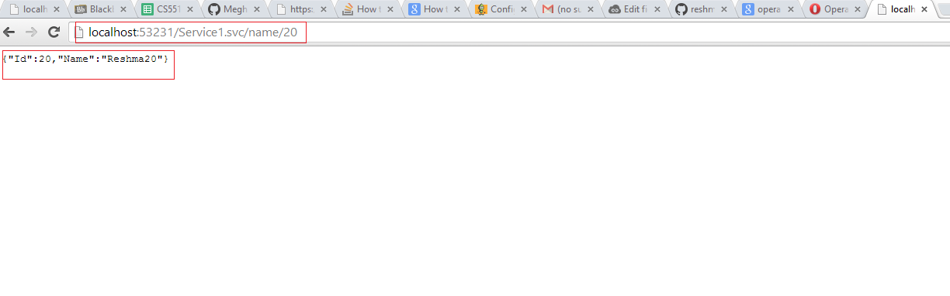

When deployeed on to the server and ran grom the server. When given a same input same out put can be seen.

